**Chapter 1: Introduction**

**1.1. Introduction**

In the past decade, information technology has growing rapidly and it is very difficult for any organization to survive without utilizing this technology. In today’s context of fast food and take-out, many restaurants have chosen to focus on quick preparation and speedy delivery of orders rather than offering a rich dining experience.

We propose an online food ordering system-Bhojan, which simplifies the ordering process for both the customer and restaurant. When the customer visits the ordering webpage, they are presented with an interactive and up-to-date menu, complete with all available options and dynamically adjusting prices based on the selected options. After making a selection, the item is then added to their order which the customers can review the details of at any time before checking out.

**1.2. Problem Statements**

* The customer must come to a restaurant and order manually.
* Customers will have to make long queues before placing their orders especially during peak hours and then the ordering staff will record customer orders.
* Having placed their order, the customer must then wait near the counter until their order is ready for collection.
* Restaurants are not realizing the efficiencies that would result from better application of technology in their daily operations.

**1.3. Objectives**

* To save customer time and effort for coming restaurant.
* To increase efficiency and improve services provided to the customers using technology.
* To be able to stand out from competitors in the food service industry.
* To reduce restaurant’s food wastage.
* To help the concept of making digital Nepal.

**1.4. Scopes and Limitations**

**1.4.1. Scope**

In the past, due to the reach of the internet among the many people in Nepal has brightened the future of online business. It noted that 63% of the total population uses internet service in Nepal. This status proves that there is good scope of online business in Nepal. On the other hand, in this fast moving world people have not much time. People prefer to spend quality time with their family rather than go to restaurant. As well as recent pandemic also increase the scope of online business.

**1.4.2. Limitation**

* Requires internet connection to operate.
* Customer must be computer literate.
* The system will only be convenient to people with a small geographical region, basically just around the restaurant.

**1.5. Report Organization**

Chapter Plan regarding our project is structured as specified in the format below:

**Chapter 1: Introduction**

This chapter consists of a brief introduction to our Project, e-business, and online platforms. This chapter also discusses the Problem definition, the objectives of the project, its scope, and limitations.

**Chapter 2: Requirement Analysis and Feasibility Study**

This chapter focuses on the study of existing systems and Projects from various sources such as internet blogs, websites, project work reports, books, and journals. It also explains the requirements specification and feasibility study conducted during project initiation.

**Chapter 3: System Design**

This chapter consists of Data Flow Diagram (DFD), and Use Case Diagram.

**Chapter 4: Implementation and Testing**

This chapter focuses on the Software, Tools, protocols that have been utilized for the initiation and completion of our Project. Also, it defines various testing of the System.

**Chapter 5: Conclusion and Future Recommendations**

This section discusses the issues that might arise and their maintenance. It focuses on adding features to the system and how the clients using our system will be supported.

**Chapter 6: References**

This section lists out references to journals, conferences, books, websites, and other sources that have been cited throughout the project.

**Chapter 7: Appendix**

This section includes the miscellaneous source codes of working modules that explain the working mechanism of our project.

**Chapter 2: Background Study and Literature Review**

**2.1. Background Study**

The online food ordering system is one of the latest servicers most fast food restaurants are adopting. With this method, food is ordered online and delivered to the customer. This is made possible through the use of electronic payment system. Customers pay with their credit cards, although credit card customers can be served even before they make payment either through cash or Cheque. So, the system designed in this project will enable customers go online and place order for their food. Due to the great increase in the awareness of internet and the technologies associated with it, several opportunities are coming up on the web. So many businesses and companies now venture into their business with ease because of the internet. One of such business that the internet introduced is an online food ordering system. In today’s age of fast food and take out, many restaurants have chosen to focus on quick preparation and speedy delivery of orders rather than offering a rich dining experience.

The system also greatly lightens the load on the restaurants end, as the entire process of taking orders is automated. Once an order is placed on the webpage that will be designed, it is placed into the database and then retrieved, in pretty much real-time, by a desktop application on the restaurants end. Within this application, all items in the order are displayed, along with their corresponding options and delivery details, in a concise and easy to read manner. This allows the restaurant employees to quickly go through the orders as they are placed and produce the necessary items with minimal delay and confusion.

**2.2. Literature Review**

Online Food Ordering System is the system where we can order the food item through internet with just one click, which can make our daily life easy and faster. Presently the customers spend an average of 1 hour per day going to the restaurant, selecting their food and paying. Some restaurants have the provision of customers making a call to the restaurant in advance to order an item to be ready for them for pick or to be delivered to them. That is too long process and not trusts worthy too and there may be lots of confusion which may not build a good relation between restaurant and the customer.

There are already many systems that provide online food ordering services. But in Nepal, there is lack of efficiency in the system and customer are not satisfied with their services. These systems are time consuming, low accuracy, complex ordering process, less interactive design and low security of customer data. That makes bad experience for the customer. However, we can see some well-functioning systems like Foodmandu, Foodmario, Bhojdeals etc. for ordering foods but they are not available in many location. So, Bhojan can be a good opportunity for both restaurant and customer of Nepal.

**Chapter 3: System Analysis and Design**

**3.1. System Analysis**

**3.1.1. Requirement Analysis**

Requirement analysis is the process of precisely identifying, defining, and documenting the various requirements that are related to a particular business objective. Requirements gathering help in clearly understanding the needs of the customer, defining the scope of the project, and assessing the timescales and resources required to complete it. There are two types of requirement which are as follows:

#### 3.1.1.1. Functional Requirement

These are the key functions that our system must fulfill. As per the objectives of our project, primary or functional requirements are:

1. **User Registration**

Registration is open to all visitors to Bhojan. Users can register to Bhojan by filling the necessary information in the Sign Up tab. User then selects appropriate Login credentials (Username and Password) to access full functionality.

1. **Searching for the food:**

The users should be able to input the desired food item and be able to search for the food.

1. **Getting the desired result:**

The user should be able to view the desired result and it must be easy to get the all items prices.

1. **Ordering the desired food item:**

The user should be able to go through different foods item and it must be easy to order desired foods.

1. **Logout:**

The user should be able to logout of the system easily.

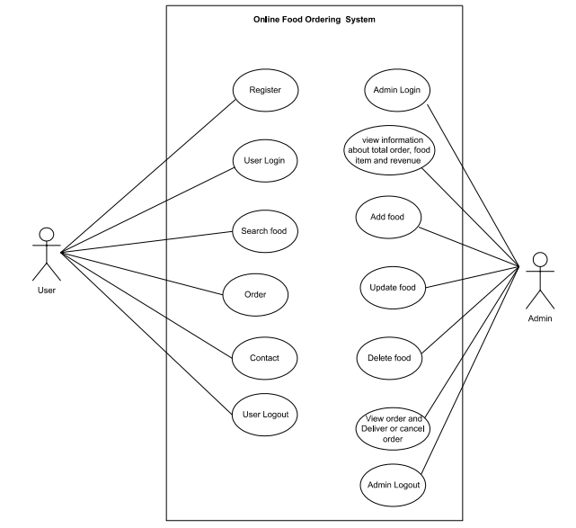

**Figure 3.1.1.1i Use Case Diagram**

#### 3.1.1.2. Non-functional Requirements

Despite the requirements discussed in the above section, there are some other secondary requirements that our system must fulfill which are:

1. **Usability**

Nowadays almost all people have knowledge about the internet and e-commerce sites. So, our project is worth to almost all age groups.

1. **Reliability**

Our website is reliable to simplify the ordering process for both the customer and restaurant.

1. **Safety**

The user information such as name, email, and password are protected and won’t be misused or shared with any third party.

1. **Performance**

Our system is optimized and uses less system resources. Hence, the tasks performed by the system are done efficiently and effectively.

1. **Maintainability**

Our system should be easy to maintain. Once visited our website, the user would be easily able to search and find their desired foods.

1. **User related requirements**

During the deployment of our project, we can configure the user interface and code to modify according to the need of the user.

**3.1.2. Feasibility Analysis**

For the success of the project, feasibility analysis was done. It is performed so that there will be no problem during the project development and in near future. The analysis performed is described below:

**i. Technical Feasibility**

Our system is technically feasible because it is within the limits of current technology, required software and hardware is easily available, there are enough manpower-programmers, testers and debuggers.

**ii. Operational Feasibility**

Our system is operationally feasible because it benefits the organization, it works within the government regulations, it makes efficient use of available resources, it offers effective controls to protect against fraud and to guarantee accuracy and security of data and information and to operate this system customer only needs web browser and internet connectivity.

**iii. Economical Feasibility:**

Economic feasibility tries to determine the positive economic benefits to the organization that the proposed system will provide. Our systems hardware and software cost less, cost of business employee time is also average. It automatically performs most task intelligently that helps to save the manpower cost. Therefore our system is cost effective and economically feasible to develop.

**iv. Schedule Feasibility**

Under schedule feasibility, we studied whether the project could be completed on time or not. If it takes too long for the completion before it becomes useful then it is better not to start the project. As per the research performed before initiating the project, we concluded with the Gantt Chart below.

|  |  |  |  |  |  |  |  |  |  |  |  |  |
| --- | --- | --- | --- | --- | --- | --- | --- | --- | --- | --- | --- | --- |
| **Week**  **Phases** | **1** | **2** | **3** | **4** | **5** | **6** | **7** | **8** | **9** | **10** | **11** | **12** |
| Study and Analysis | **2w** |  |  |  |  |  |  |  |  |  |  |  |
| Data fetching and scrapping |  |  | **3w** |  |  |  |  |  |  |  |  |  |
| Implementation |  |  |  | **3w** |  |  |  |  |  |  |  |  |
| Testing |  |  |  |  |  | **4w** |  |  |  |  |  |  |
| Documentation |  |  |  |  |  |  |  | **10w** |  |  |  |  |
| Review |  |  |  |  |  |  |  |  |  |  | **3w** |  |
| Presentation | **1w** |  |  | **1w** |  |  |  |  |  |  |  | **1w** |

**Table 3.1.2. Gantt Chart**

**3.1.3. Data Modeling(ER-Diagram)**

An entity relationship model is a graphical representation of entities and their relationships to each other, typically used in computing in regard to the organization of data within databases or information systems. An entity is a piece of data, an object or concept about which data is stored and a relationship is how the data is shared between entities.

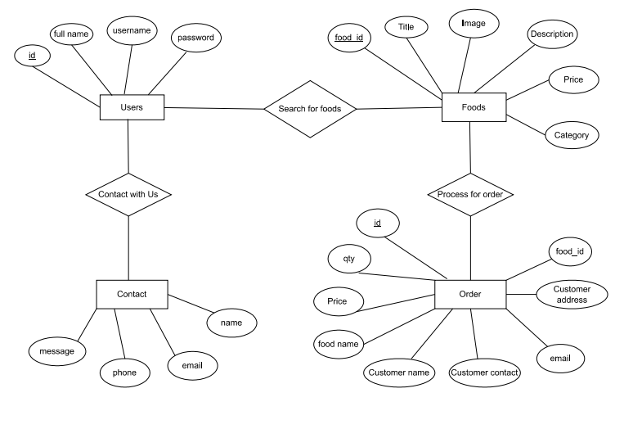

**Figure 3.1.3 ER Diagram**

### 3.1.4 Process Modeling (DFD)

Process modeling is used to describe how things must/should/could be done in contrast to the process itself which is really what happens. A process model is roughly an anticipation of what the process will look like. The process modeling of the application is done through DFD diagrams.

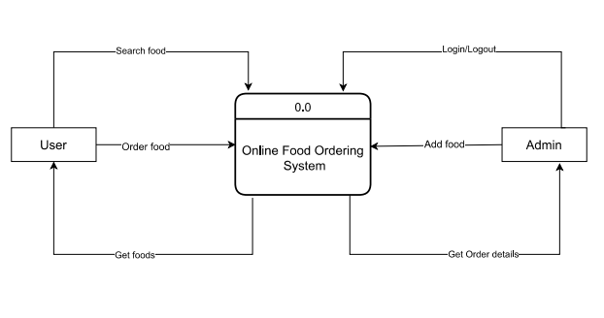

**Figure 3.1.4.i Level 0 Data Flow Diagram**

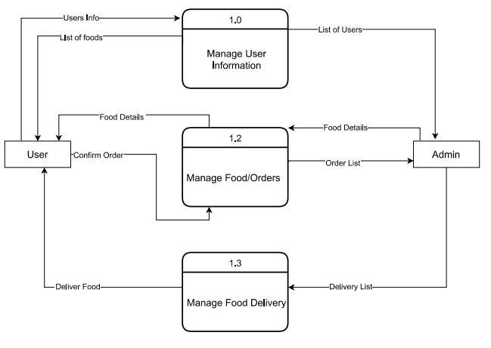

**Figure 3.1.4.ii Level 1 Data Flow Diagram**

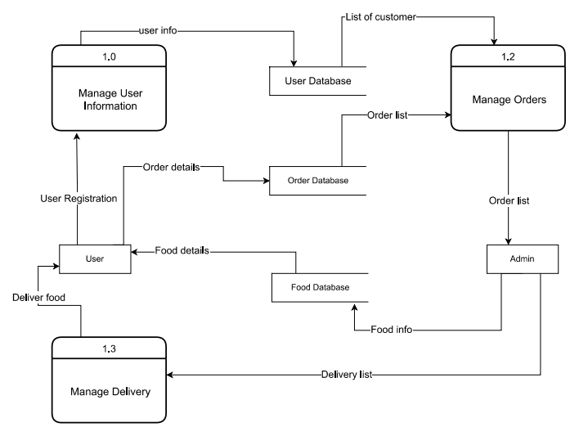

**Figure 3.1.4.iii Level 2 Data Flow Diagram**

## 3.2. System Design

This chapter deals with the module, database design, user interface design and the program design. For the designing of the application, various diagrams like use case diagram, schema diagram,, DFD etc. have been used.

**3.2.1. Architectural Design**

We have developed the required system that makes use of the internet and computer peripherals, and smartphones. This system can be used by any device like computer, smart phone etc. that can access the internet.

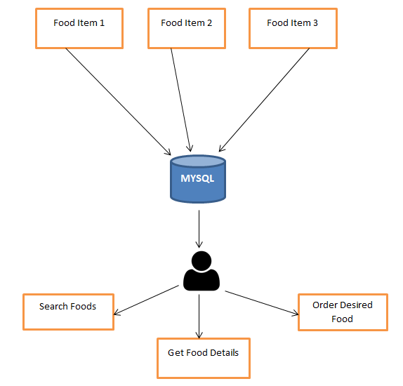

**Figure 3.2.1 Architecture Design**

**3.2.2. Database Schema Design**

A database schema is the skeleton structure that represents the logical view of the entire database and defines how the data is organized and how the relations among them are associated.

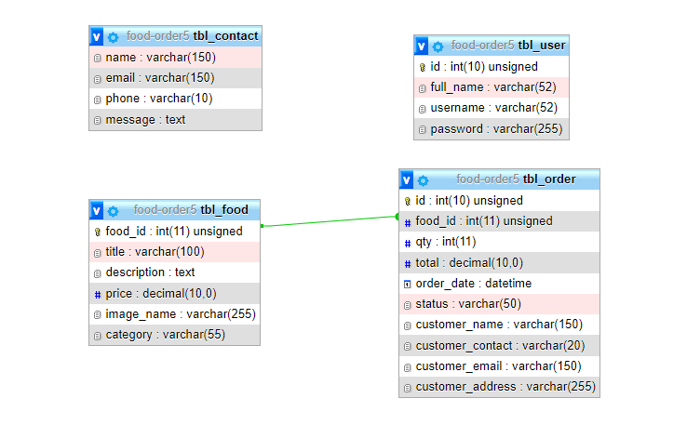

**Figure 2.2.2 Database Schema Diagram**

**Chapter 4: Implementation and Testing**

**4.1. Implementation**

For the implementation of this project, we are using programming languages like html, css, javascript, php. Mysql is used for databases.

**4.1.1. Tools Used( CASE Tools, Programming Language, Database Platforms)**

* IDE: Visual Studio Code
* Operating System: Windows or Linux
* Font End: HTML, CSS, JavaScript
* Database: MySql
* Back End: Php

**4.2. Testing**

Software testing is the process of evaluating a software item to detect differences between given input and expected output. It also assesses the features of a software item.

**4.2.1. Test Cases for Unit Testing**

**Table 4.2.1. Test Cases for Unit Testing**

|  |  |  |  |  |  |  |
| --- | --- | --- | --- | --- | --- | --- |
| **S.N.** | **Test Scenario** | **Test Case** | **Test Data** | **Expected Result** | **Actual Result** | **Pass/Fail** |
| 1 | Check Login Functionality | Check response on entering valid username and password | Username: ram  Password: ram123 | Login Must Be Successful | Login Successful | Pass |
| 2 | Check Login Functionality | Check response on entering invalid username and invalid password | Username: ram  Password: abcdef | The system must prompt username or password error | Prompted “Invalid username and password” | Pass |
| 3 | Check Login Functionality | Check response on entering valid username and empty password | Username: ram  Password: | The system must prompt password is empty error | Prompted “Please fill out this field” | Pass |
| 4 | Check Login Functionality | Check response on entering empty username and valid password | Username:  Password: ram123 | The system must prompt username is empty error | Prompted “ Please fill out this field ” | Pass |
| 5 | Check Login Functionality | Check response on entering invalid username and valid password | Username: hari  Password: abcdef | The system must prompt username or password error | Prompted “Invalid username and password” | Pass |

**4.2.2. Test Cases for System Testing**

System Testing is a black box testing technique performed to evaluate the complete system's compliance against specified requirements. In System testing, the functionalities of the system are tested from an end-to-end perspective. The system testing has been performed by testing the whole application with and without the internet connection. The whole application runs smoothly and without error with the internet connection. Without the internet connection, the application cannot perform fully. Since the data is synchronized when the application connected to the internet, so without the internet connection the application cannot function fully.

**Table 4.2.2 Test Case for System Testing**

|  |  |  |  |  |  |  |
| --- | --- | --- | --- | --- | --- | --- |
| **S.N**. | **Test Scenario** | **Test Case** | **Test Data** | **Expected Result** | **Actual Result** | **Pass/Fail** |
| 1 | Register with previously used Username | Check response on entering already used Username | 1st registration Username: ram  2nd registration Username: ram | Error message must be displayed | Error message called “Username already exits  ” | Pass |
| 2 | Search Foods Items | Search for required items on search bar | search items: Pizza | Available result for Pizza  must present | Get result for Pizza | Pass |
| 3 | Order Foods | Order desired foods item | searched item Pizza  ordered. | Order details must be displayed on the manage order page of admin dashboard | Ordered Pizza details displayed on the manage order page | Pass |

**Chapter 5: Conclusion and Future Recommendation**

**5.1. Lesson Learnt / Outcome**

This project is made using programming language Php. This is powerful programming language and will perform more efficiently while performing tasks such as ordering food, fetching data from database. The front end is made with the use of html, css and javascript where the user will be able to input the name of the food they want and after which the Bhojan will start finding their requirement in database. The data will include food details such as their price, images, descriptiong etc.The user information is saved into the Mysql database which is secured and the information will be stored for future use.

**5.2. Conclusion**

Online food ordering systems help to simplifies the ordering process for both the customer and restaurant. It is always not easy for a customer to come restaurant, order manually, make long queues before placing their order and having placed their order, the customer must then wait near the counter until their order is ready for collection. Customer ordering from Bhojan visits the ordering website, they are presented with an interactive and up-to-date menu, complete with all available option and dynamically adjusting prices based on the selected options. After making a selection, the item is then added to their order which the customers can review the details of at any time before checking out.

**5.2. Future Recommendation**

The potential of IT is unlimited. In the future, we will try to accommodate all of the best restaurants of Nepal. Since affiliate marketing is becoming very popular in other countries, we can try to do affiliate marketing in the sites of Nepal, which will make our website to grow even more further. Along with this, we will make our service available many location.

**Chapter 6: References**

x

|  |  |
| --- | --- |
| [1] | Alagoz, Murat Serhat, and Hekimoglu Haluk, "Online Food Ordering System," A study on tam: analysis of customer attitudes in online food ordering system, pp. 1138-1143, 2012. |
| [2] | Raharjo, Dwi Willy, and Wardhana Ariyani , "Online Food Ordering System Requirements Specification," An Analysis of Design Android Food Ordering Applications At Taichan Kumis Restaurant, pp. 94-108, 2018. |
| [3] | Kumar and Pradeep Pankaja , "how to use gantt chart," Effective use of Gantt chart for managing large scale projects, p. 14, July 2005. |

x

**Chapter 6: Appendix**

**7.1. System Snapshots and Explanation**

Initially our website starts with home page. In the home page we have website logo, menu, search bar, login button, image slider and most popular foods item. User can search or manually find desired food item and place order. Before ordering food, user must be login.

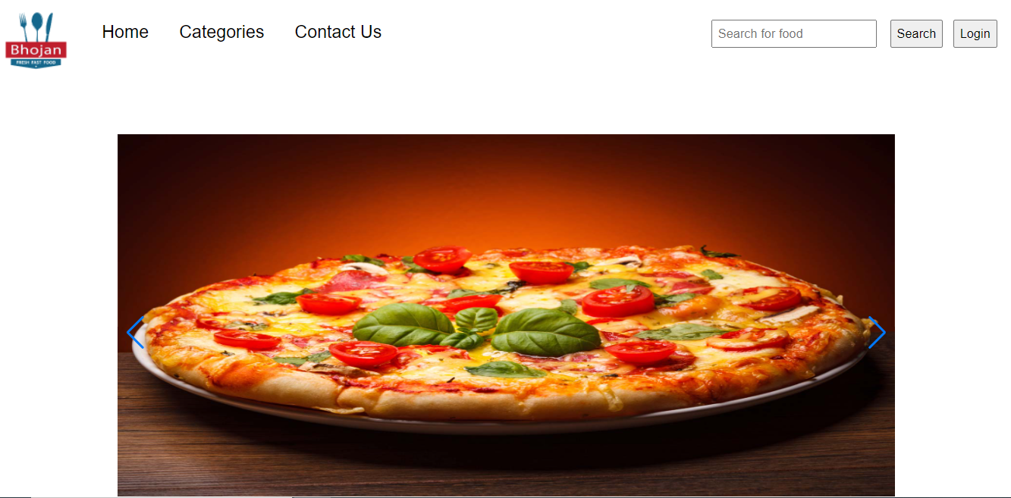

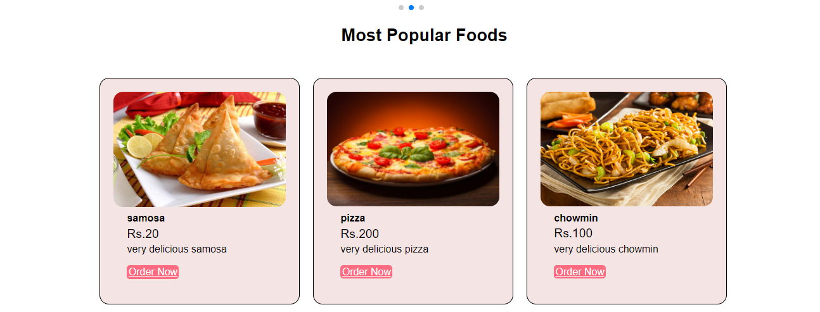

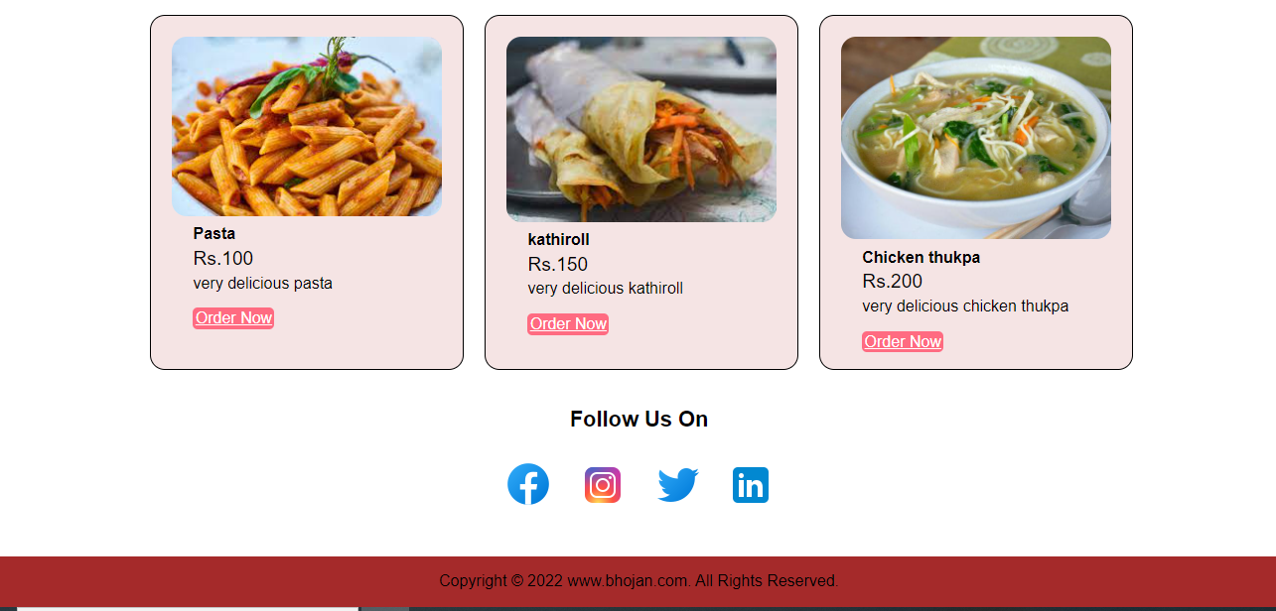

**Figure 7.1.i Home Page**

This is starting page of our website.

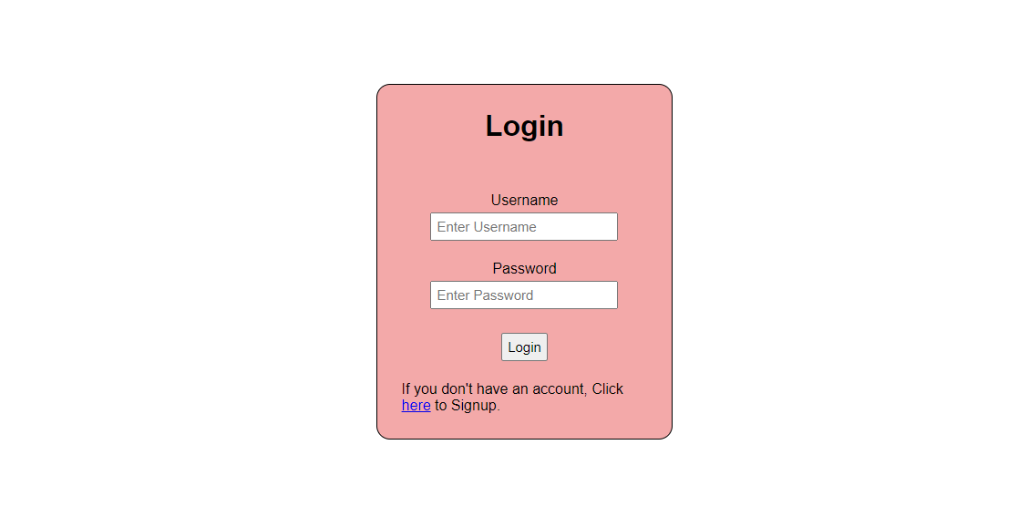

**Figure 7.1.ii User Login Page**

This is our website login page.

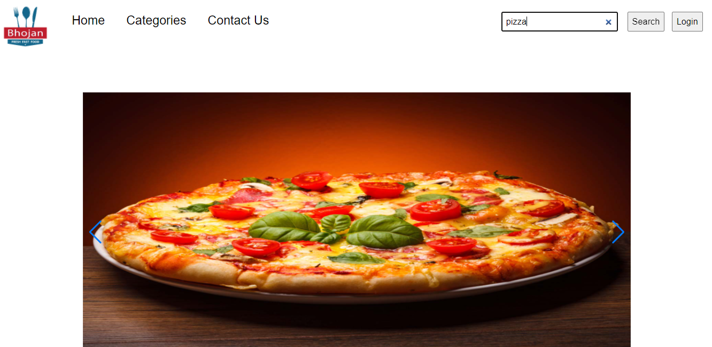

**Figure 7.1.iii Home Page**

This is our home page where user can search food.

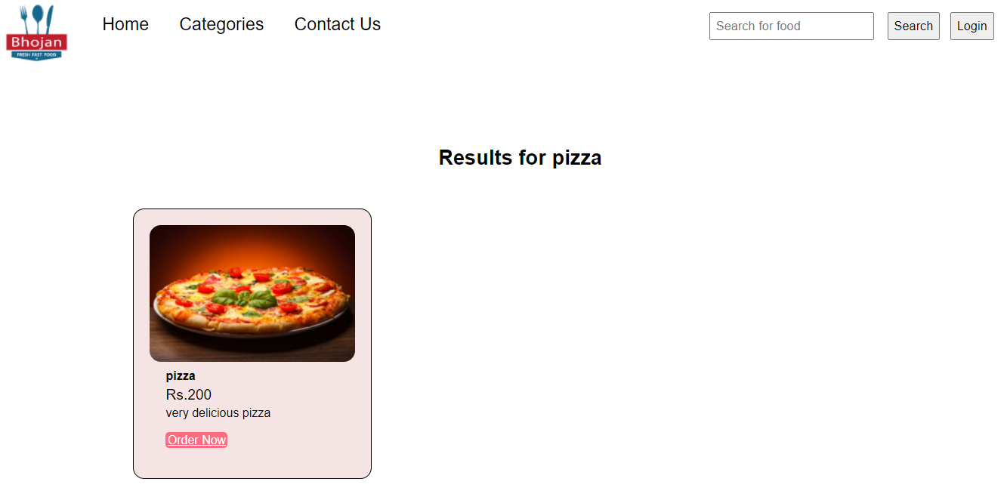

**Figure 7.1.iv Search Result Page**

This is search result page after user searches for the food.

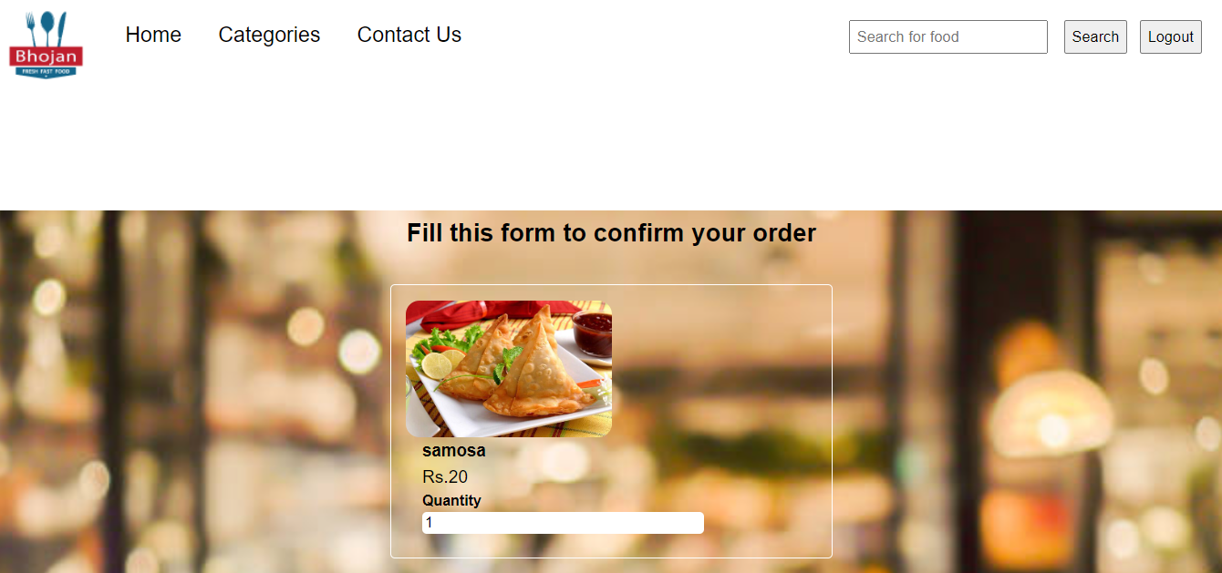

**Figure 7.1.v Order Page**

This is order page where user can place order desired food.

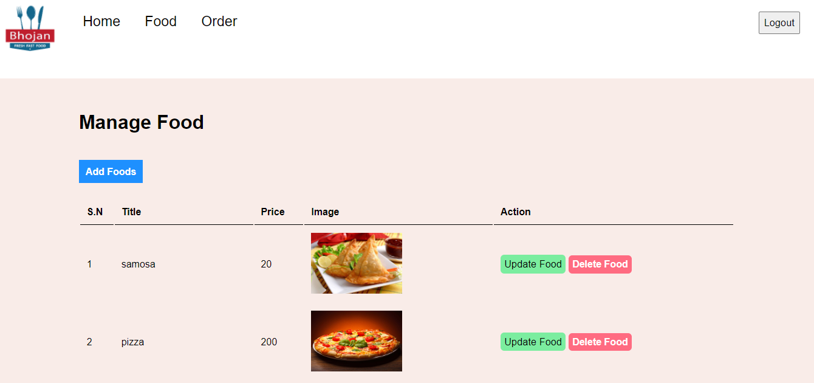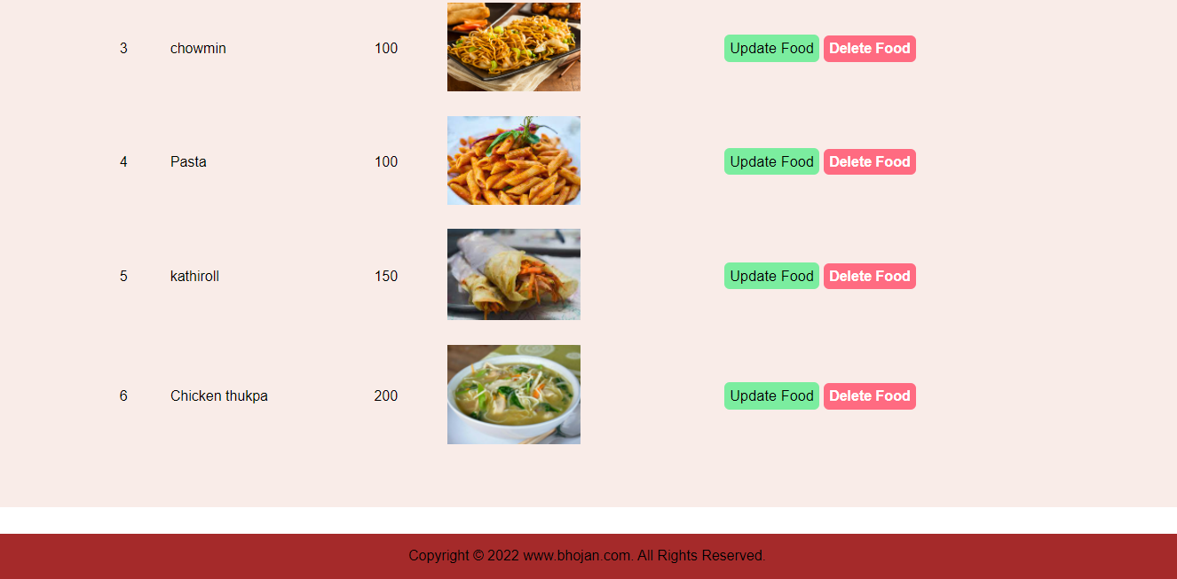

**Figure 7.1.vi Manage Food Page**

This is a manage food page from where admin can add, update, delete food.

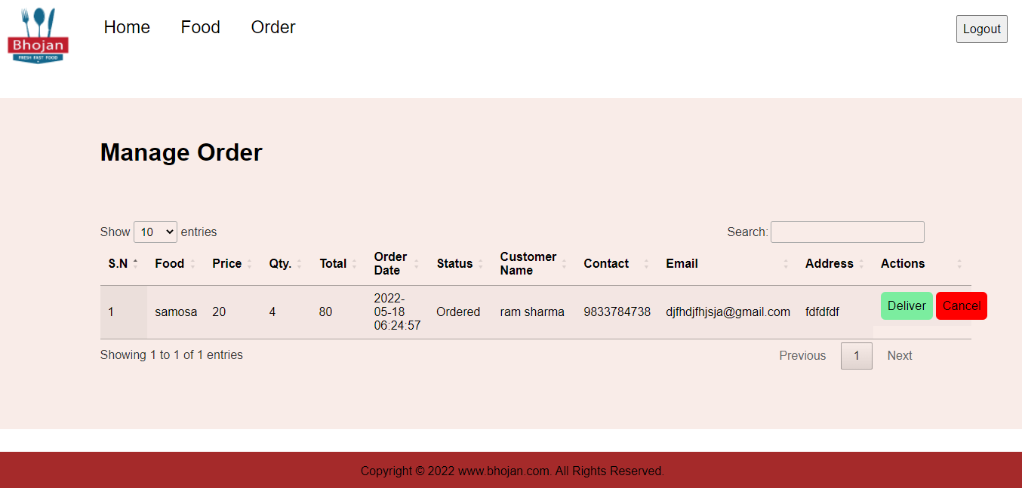

**Figure 7.1.vii Manage Order Page**

This is a manage order page from where admin manage orders.

**7.2. Source Code**

**7.2.1. Users Page**

**constants.php**

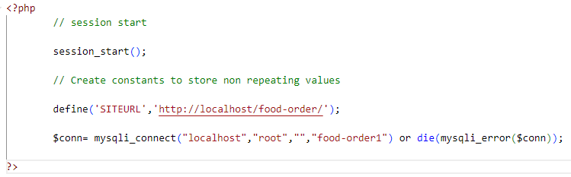

**menu.php**

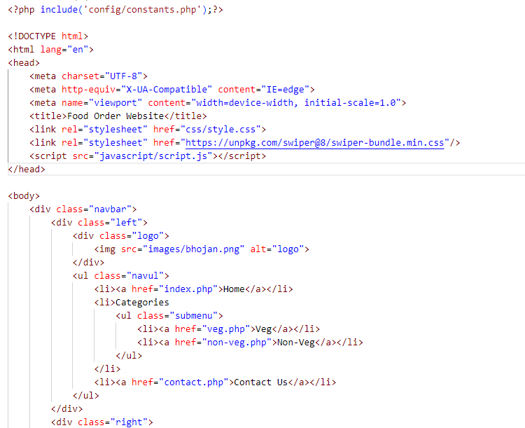

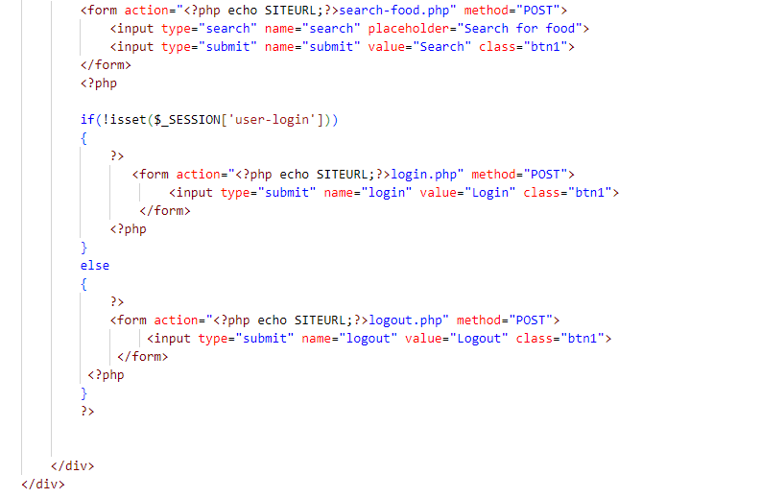

**footer.php**

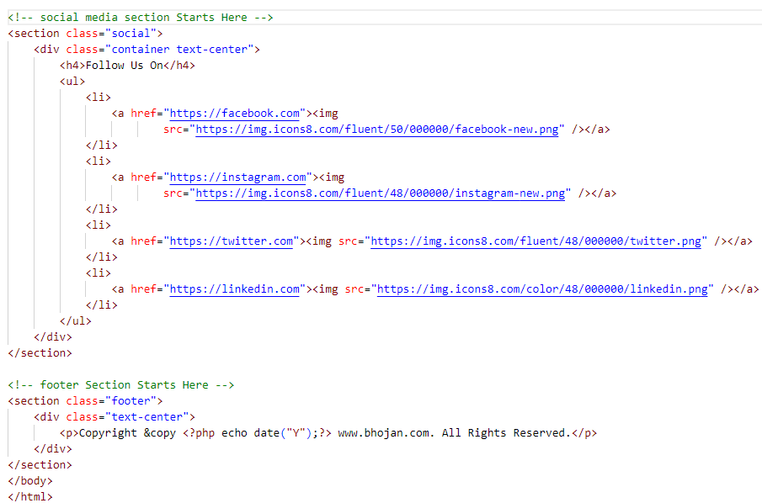

**index.php**

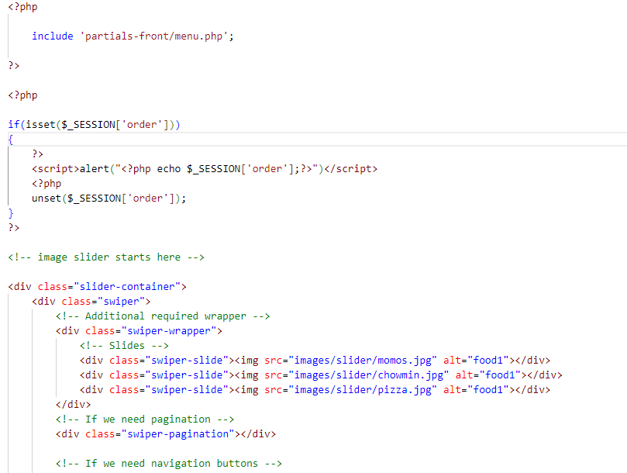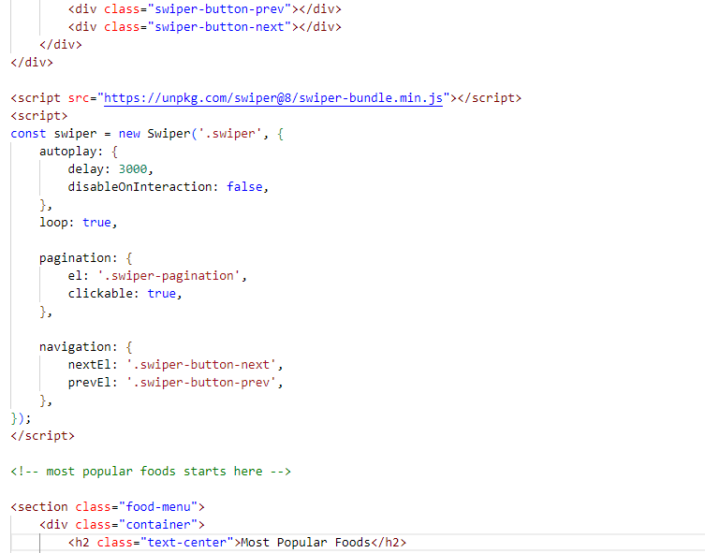

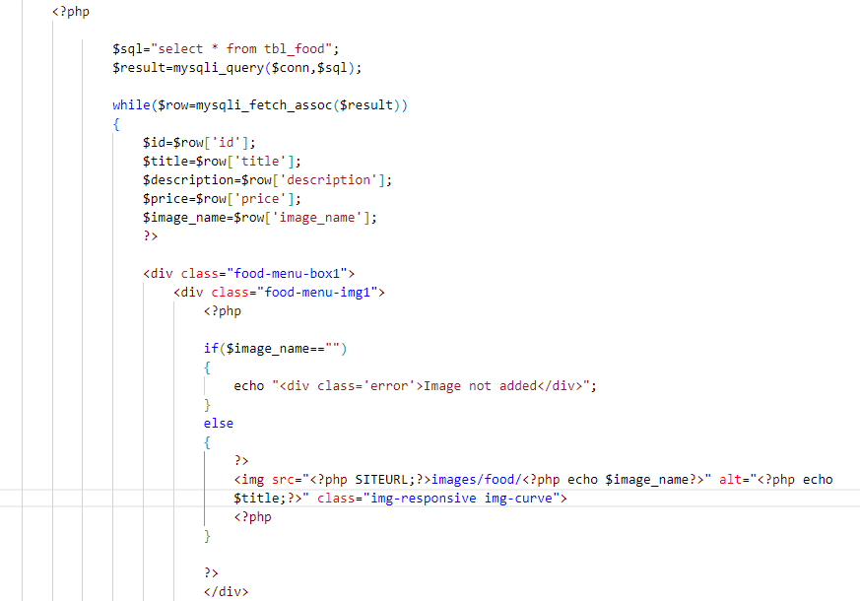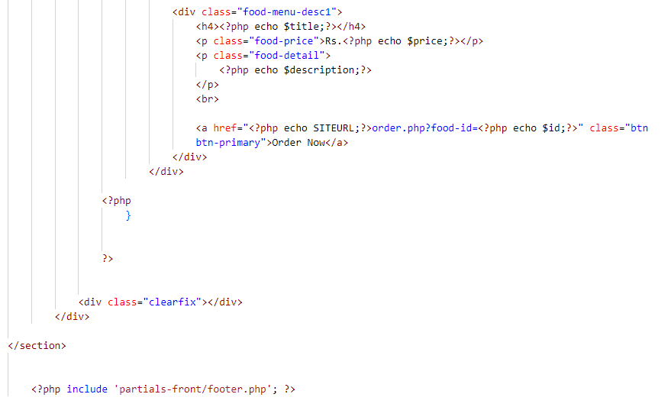

**login.php**

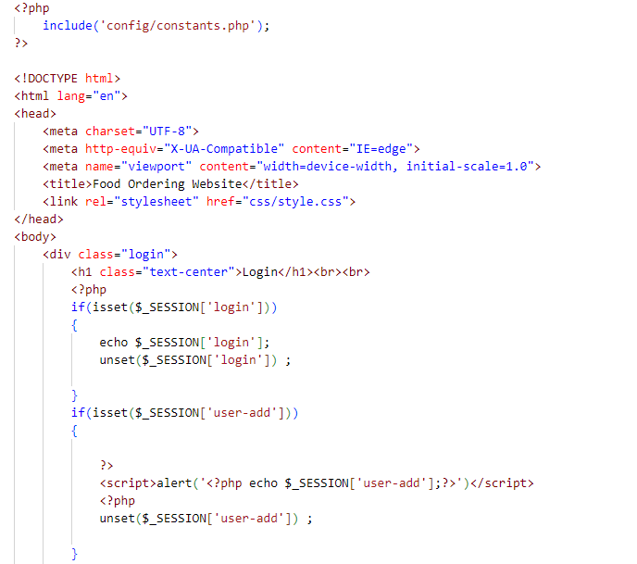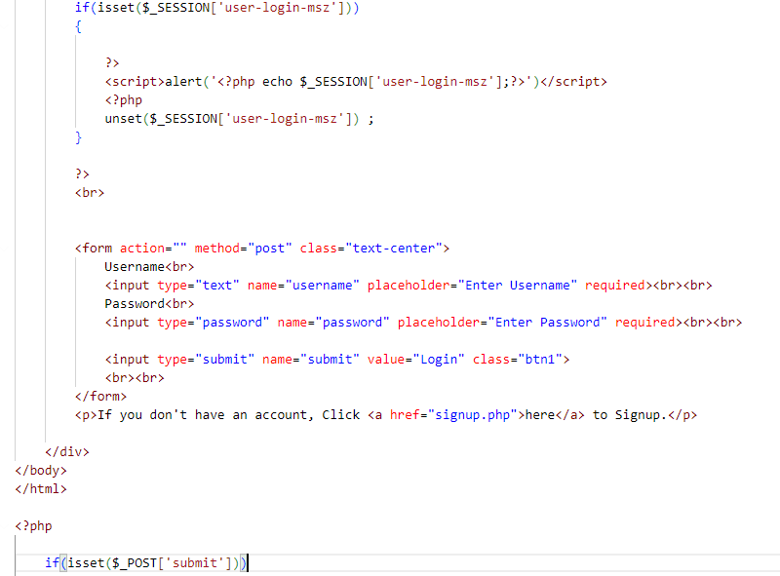

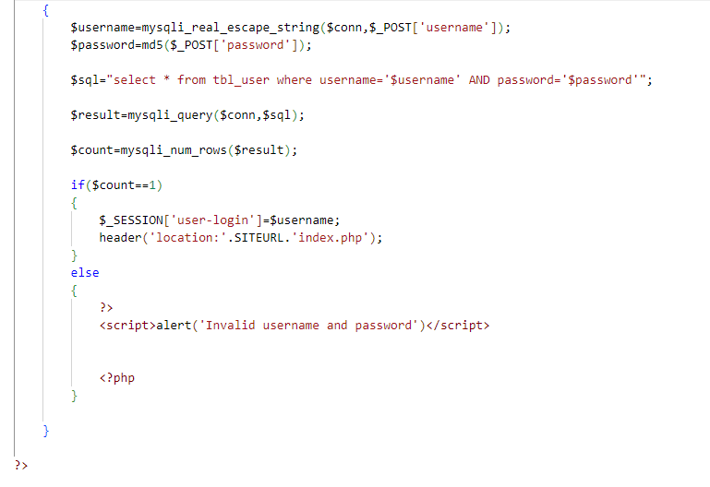

**style.css**

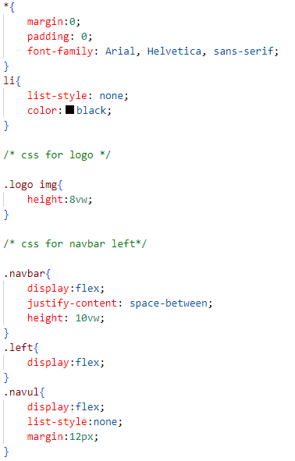

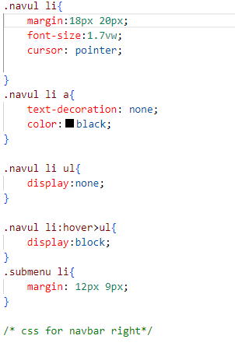

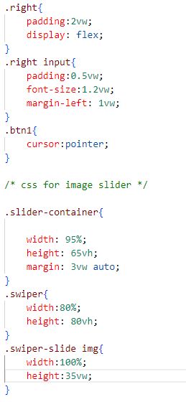

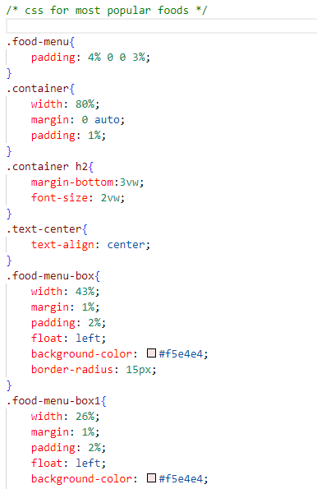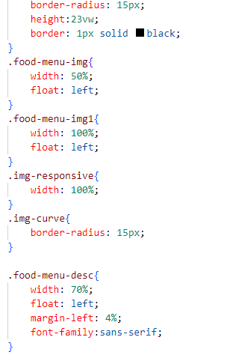

**script.js**

